

**ITES**

Facilitator’s Guide

**Functional Skills Training**

|  |  |  |  |
| --- | --- | --- | --- |
| Version | Date | Author | Change Status |
| 1.0 |  |  |  |

ABOUT THIS GUIDE 6

**TABLE OF CONTENTS**

LEGEND 7

THE DOCUMENTS – NAME & DESCRIPTION 10

SESSION SCHEDULE 11

TOPIC 1 – SESSION INTRODUCTION 13

SUBTOPIC 1: PARTICIPANTS’ INTRODUCTION 13

TOPIC 2 – INTRODUCTION TO CSS 16

SUBTOPIC 1: WHAT IS CSS? 16

SUBTOPIC 2: IN THIS SESSION – SESSION OBJECTIVES 17

SUBTOPIC 3: ASSUMPTIONS 18

SUBTOPIC 4: REQUIREMENTS 19

SUBTOPIC 5: FREQUENTLY ASKED QUESTIONS (FAQs) 22

TOPIC 3 – DEFINING STYLES 23

SUBTOPIC 1: WHY USE CSS? 24

SUBTOPIC 2: WHY DEFINE CSS? 25

SUBTOPIC 3: CSS SYNTAX 28

SUBTOPIC 4: SELECTORS 30

SUBTOPIC 5: WEB PAGE WITH CSS 31

TOPIC 4 – CSS PROPERTIES 32

SUBTOPIC 1: TEXT 33

SUBTOPIC 2: FONT 40

SUBTOPIC 3: BACKGROUND 46

SUBTOPIC 4: PADDING 48

SUBTOPIC 5: BORDER 50

SUBTOPIC 6: LIST 52

SUBTOPIC 7: LINKS 54

SUBTOPIC 8: TABLE 56

SUBTOPIC 9: POINTS TO CONSIDER 59

TOPIC 5 – PAGE LAYOUT 60

SUBTOPIC 1: PAGE SIZE AND SCREEN RESOLUTION 60

SUBTOPIC 2: DESIGNING PAGES 61

SUBTOPIC 3: SKETCHING POSITION OF AN ELEMENT ON GRID 63

SUBTOPIC 4: CODING YOUR PAGE 64

TOPIC 6 – NAVIGATION IN CSS 65

SUBTOPIC 1: NAVIGATION ELEMENTS 65

TOPIC 7 – DESIGN CONSIDERATIONS 67

SUBTOPIC 1: TABLES 67

SUBTOPIC 2: HEADINGS 68

SUBTOPIC 3: SHADING ALTERNATE ROWS 69

SUBTOPIC 4: FORMS 71

SUBTOPIC 5: CREATING A STYLE SHEET 75

SUBTOPIC 6: TYPES OF STYLE SHEETS 77

SUBTOPIC 7: POINTS TO REMEMER 78

TOPIC 8 – USING INLINE CSS 79

SUBTOPIC 1: WHAT IS AN INLINE CSS? 80

SUBTOPIC 2: HOW TO USE AN INLINE STYLE? 81

TOPIC 9 – USING INTERNAL CSS 82

SUBTOPIC 1: WHAT IS AN INTERNAL CSS? 83

SUBTOPIC 2: HOW TO USE AN INTERNAL CSS? 84

TOPIC 10 – USING EXTERNAL CSS 85

SUBTOPIC 1: WHAT IS AN EXTERNAL CSS? 86

SUBTOPIC 2: HOW TO USE AN EXTERNAL CSS? 88

TOPIC 11 – MODULE SUMMARY 89

SUBTOPIC 1: RECAP 89

SUBTOPIC 2: FINAL TIPS AND SUMMARIZATION 87

TOPIC 12 – CHECK YOUR UNDERSTANDING: 92

LAB EXERCISES 93

ABOUT THIS GUIDE

This Facilitator’s Guide addresses an ILT program of 100 hours duration based on the **ITES Functional Skills Training** course. The program can be divided into 10 sessions.

There should be 25 - 50 participants in this program.

**Please Note:** Some of the group activities may be better facilitated with an even number of participants.

This Facilitator’s Guide will help you give the participants a thorough understanding of the basic functional skills required in the ITES industry.

The features of this guide are as follows:

* It provides hands on experience of the basic Web Design functional skills that are required in the ITES industry.
* It provides references to the page numbers of the ILT version of this program. You can discuss the points as mentioned in this guide when displaying the various screens in the course.
* It includes activities that you can conduct in the class and instructions to carry out the activities.
* It includes a ‘Check Your Understanding’ section which the facilitator can conduct as a quick quiz to test the learner’s understanding of the concepts that are taught in the class.
* It provides the approximate duration of each topic. (However, the duration may vary depending on the length of discussion and/or questions that the participants might have on a particular topic.)
* It includes an explanation for the icons used in the guide. These icons will help you distinctly identify the instructions that need to be followed when explaining a section. The icons are explained on the next page.

The following legend explains the various icons used in this guide.

LEGEND

|  |  |
| --- | --- |
| Icon | Description |
|  | Approximate duration of each section |
|  | Project course screen |
|  | Discussion |
|  | Flipchart |
|  | Group Activity |
|  | Activity |
|  | Student’s Guide |
|  | Checklist |
|  | Tips for the Facilitator |
|  | Important |



GENERAL REQUIREMENTS

* Reach the training venue at least half an hour before the training commences.
* Check that the electrical connections in the room are working.
* Check the temperature of the room and ensure that it is comfortable.
* Keep in place all the required items - white board markers, duster, pens, flip chart sheets, flip chart stand, printouts, etc.
* Check that the computer you are going to display the presentation on is working.
* Check the projector and keep it ready for use.
* Carry the ILT version of the course on your computer, and have it ready for use.
* Ensure that you have gone through the entire course and mapped it to this guide. Be sure of what you need to do on each screen of the course.
* Ensure that all reference documents are kept in a single folder, along with the ILT version of the course for you to easily access during the training session.
* Take print outs of the guides/worksheets for the students and carry the required number of Student’s Guides to the room.
* Print the Facilitator’s Guide document.
* Keep a list of the names of the participants as a reference for yourself to help you identify them.



**PLEASE NOTE:** It is vital that you go through both the course and this guide thoroughly before you conduct your first session. This will increase your confidence while delivering the training.



* **Review** the instructions and activities listed in this Facilitator’s Guide.
* **Ensure** that you have all the teaching aids required for the session. The required teaching aids are:
* ILT package for the course
* PC and LCD Projector machine and screen
* Copies of the **Participant’s Guide** (one for each participant and a copy for yourself)
* **Activity** and **Response Sheets** (cut-outs wherever required)
* Whiteboard or flipcharts
* Stationery items like pens, pencils, whiteboard markers, etc.
* **Review** the ILT version of the course to familiarize yourself with the information provided on each screen. Each screen is referenced in this guide. This will enable you to refer to the relevant screen when explaining it to the participants.



* “**Notes**” sections have been provided at various points in this guide. Note down points that you think are important and need to be further explained in the session.
* **Check** that the computer on which you are going to display the ILT is working and connected to the LCD projector.

# 

THE DOCUMENTS – NAME & DESCRIPTION

* **ITES_WebDesign_ CSS.pptx**: This is the ILT version of the course that should be used for the session.
* **ITES_WebDesign_ CSS_Participant'sGuide.docx:** This is the Participant’s Guide for the session.

[**Please Note:** Distribute this document after discussing the Program Schedule (Keep a copy of the schedule on the Flipchart for reference)].

SESSION SCHEDULE

|  |  |  |
| --- | --- | --- |
| **Topic** | **Sub-topic** | **Duration in minutes** |
| 1. Session Introduction | * Participants’ Introduction * Ice Breaker | 15 minutes |
| 1. Introduction to CSS | * What is CSS? * Session Objectives * Assumptions * Requirements * FAQs | 15 minutes |
| 1. Defining Styles | * Why use CSS? * Why define CSS? * CSS Syntax * Selectors * Web Page with CSS * Inheritence | 120 minutes |
| 1. CSS Properties | * Text * Font * Background * Padding * Border * List * Links * Creating a Style Sheet * Types of Style Sheets * Table | 5 minutes |
| 1. Page Layout | * Points to consider * Page Size and Screen Resolution * Designing Pages * Sketching Position of an Element on Grid * Coding Your Page | 5 minutes |
| 1. Navigation in CSS | * Navigation Elements | 10 minutes |
| 1. Design Considerations | * Tables * Headings * Shading Alternate Rows * Forms |  |
| 1. Using Inline CSS | * What is an Inline CSS? * How to Use an Inline Style? |  |
| 1. Using Internal CSS | * What is an Internal CSS? * How to Use an Internal CSS? |  |
| 1. Using External CSS | * What is an External CSS? * How to Use an External CSS? * Points to Remember |  |
| 1. Summary | * Recap * Final Tips and Summarization | 10 minutes |
| 1. Check Your Understanding |  |  |
| **Total duration** | | **75 minutes** |



Present the program schedule for the session. Begin the session with a discussion on the detailed structure of the program and the topics to be covered here. (You can copy the schedule table into a PowerPoint presentation to project the schedule on the screen.)



**NOTE:** Due to the nature of the training, we have not marked the breaks in the schedule. Thus, the total time for the session is approximately 3 hours.   
Please distribute these breaks as per your discretion.



* Distribute the following to the participants:
* ITES_WebDesign_CSS_Participant'sGuide.docx (Printouts)
* Pens
* Notepads

## 

## 

Project the ILT course.

TOPIC 1 – SESSION INTRODUCTION

**TOPIC 1 – CSS**

SUBTOPIC 1: PARTICIPANTS’ INTRODUCTION



* Play the intro animation.Welcome the participants to the ILT Session on **ITES** - **Basic Functional Skills – CSS** by saying “Welcome to the course on Web Design. Today, we will introduce the basic concepts of CSS
* Introduce yourself to the participants. Share your name, and a brief professional profile, including: designation, tenure in the organization, domain of work, etc. (especially if most of the participants are unknown to you.)
* Now, have the participants take part in the activity described below.

**NOTE:** You can either use your own idea/concept to do this, or use one of these activities. We are assuming that the participants by now know each other, and therefore, there’s no need for any introductions, etc. Also, it is important for you to set an example. So, for the activities, regardless of which one is chosen, you should lead and demonstrate an example of the activity.



* **Describe your partner…**

Divide the group into pairs. Give 5 minutes to all the pairs. Ask each pair to talk to each other and learn interesting fact/details about each other.

Next, invite each pair and ask each participant to prefix their partner’s name with another word that describes him/her, or his/her hobby interest. The twist is that the initial letter of the name must be the initial letter of the characteristic. For example: Fabulous Farheen, Adventurous Alia.

Once they have thought of the new names, ask them to explain why they have chosen that particular characteristic of their respective partners.



**NOTE:**

This activity is meant to get participants “hooked” onto the session from the very start. Thus, you must ensure that each participant is actively joining in, and **having** **fun** while doing it.

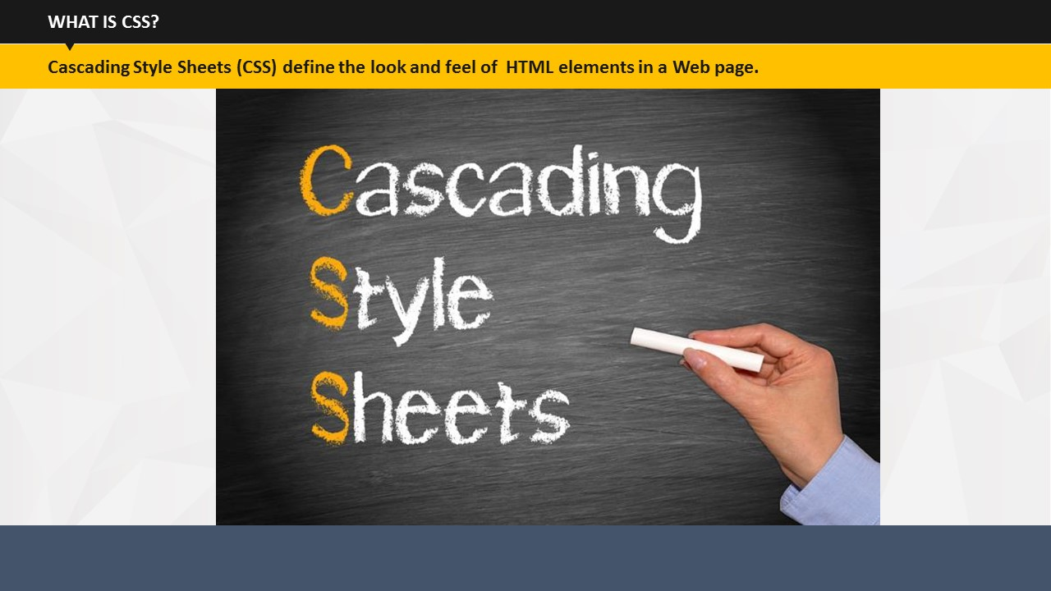

SUBTOPIC 1: WHAT IS CSS?

TOPIC 2 – INTRODUCTION TO CSS

**Say:** Have you ever come across such sites on Internet that caught your attention due to their design, color combinations, layouts, choice of fonts etc.?   
**Do**: Invite participants to share the name of such sites which impressed them by their overall presentation of content. Name some yourself.

**Say:** So, what could be the reasons behind the impressive presentation of content on these and many more such sites? We can definitely say a talented web designer with wonderful visualization skills! But a CSS is equally necessary to give a nice look and feel to the content presentation on the websites.

**Say:** So, what exactly is CSS and how does it helps web designer?   
  
**Do**: Invite participants to come up with the full form of CSS and define it.

**Say:** CSS or Cascading Style Sheets are used to define the look and feel of HTML elements in a webpage. In other words, CSS is a simple language used to write certain formatting instructions. These instructions are picked up by the browsers to define the look and feel of the webpages.

**Do**: Reveal the definition of CSS on the screen.

## 

SUBTOPIC 2: IN THIS SESSION – SESSION OBJECTIVES

**Say:** Let us begin by outlining the main learnings of this session. This will help you understand what tasks you will be able to perform after completing this session.

1. **Say:** In this session, you will learn what is CSS,
2. **Say:** …why you need it…
3. **Say:** …and how can you define it.
4. **Say:** You will also learn about different types of style sheets.



**Do:**

* Invite participant’s inputs on the objectives – asking them to state their own objectives/problem areas. In case such objectives/problem areas are relevant, write them on the flipchart. Remember to cover such points at the appropriate time in the training session. Also, remember to discuss them again during summarization.
* You can refer to these objectives during the summarization session to know whether the objectives have actually been met or not.

## 

SUBTOPIC 3: ASSUMPTIONS

**Say:** At the beginning of this session, I am assuming that you have an understanding of HTML. To write a style sheet, it is important for you to have a working knowledge of HTML since we will be dealing with a lot of codes.

**Do:** Tell the assumption to the participants. Explain the reason for making this assumption and get their approvals on the same.

## 

SUBTOPIC 4: REQUIREMENTS

**Say:** Before learning about CSS, it is extremely important that you know what tools are basically required for creating a CSS. To continue with your understanding of CSS, you will obviously need a personal computer.

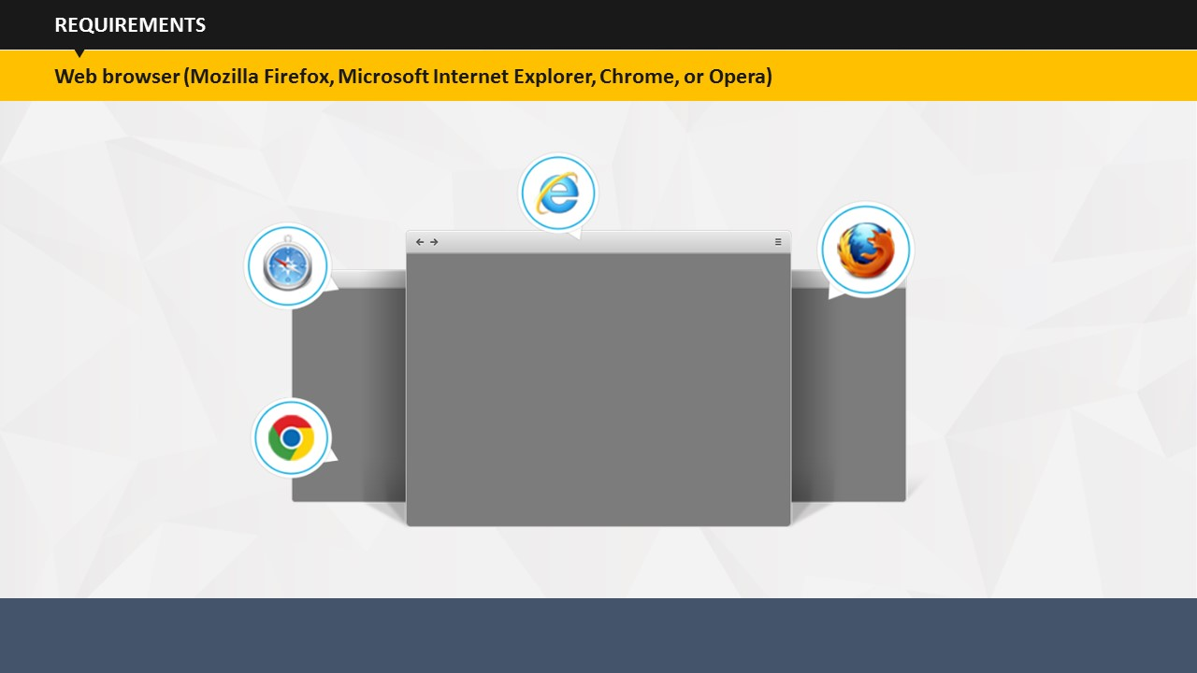

**Say:** Along with a personal computer, you will also need a Web browser, such as Google Chrome, Mozilla Firefox, Internet Explorer, etc.

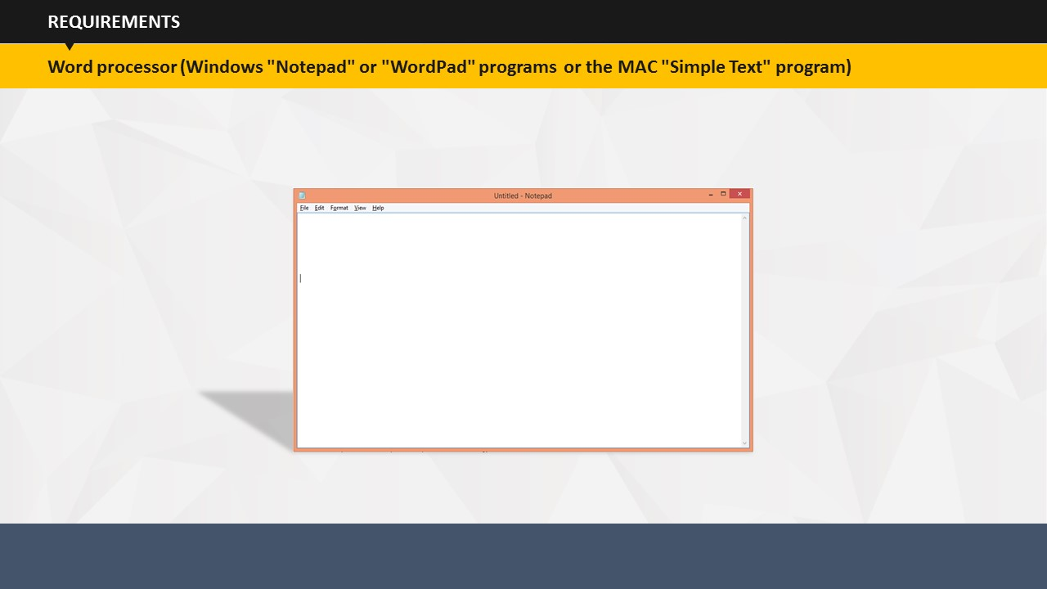

**Say:** Now that you have a personal computer and a Web browser, the only thing needed now is a word processor. If you have access to Windows "Notepad" or "WordPad" programs or the MAC "Simple Text" program, you can use that to get started.

## 

SUBTOPIC 5: FREQUENTLY ASKED QUESTIONS (FAQs)

**Say:** I am sure you must have a lot of questions on your mind right now. Let me try and address some of them.

1. Do I need to know HTML to understand the concept of CSS?  
   Yes. It is essential to have a working knowledge of HTML to be able to write instructions/rules for a CSS.
2. Must I be logged onto the Internet to do this? More specifically, will learning this increase my Internet usage cost?  
   Neither. You will write or work offline.
3. Do I need some sort of expensive program to help me write this?  
   No. You can write using Notepad or WordPad.

# 

TOPIC 3 – DEFINING STYLES

**Say:** We will now learn how to define style sheets and why is it important to define them.

## 

SUBTOPIC 1: WHY USE CSS?

Say: Styles are added to HTML to solve different issues

External Style Sheets are stored in CSS files

Saves a lot of work

Say: So, you can use CSS to define styles for your documents, including design, layout, and other variations in display for distinct devices and screen sizes. Place the CSS in the <head> of a document with the embedded style sheet, or attach a separate file, which defines the styles with an external style sheet.

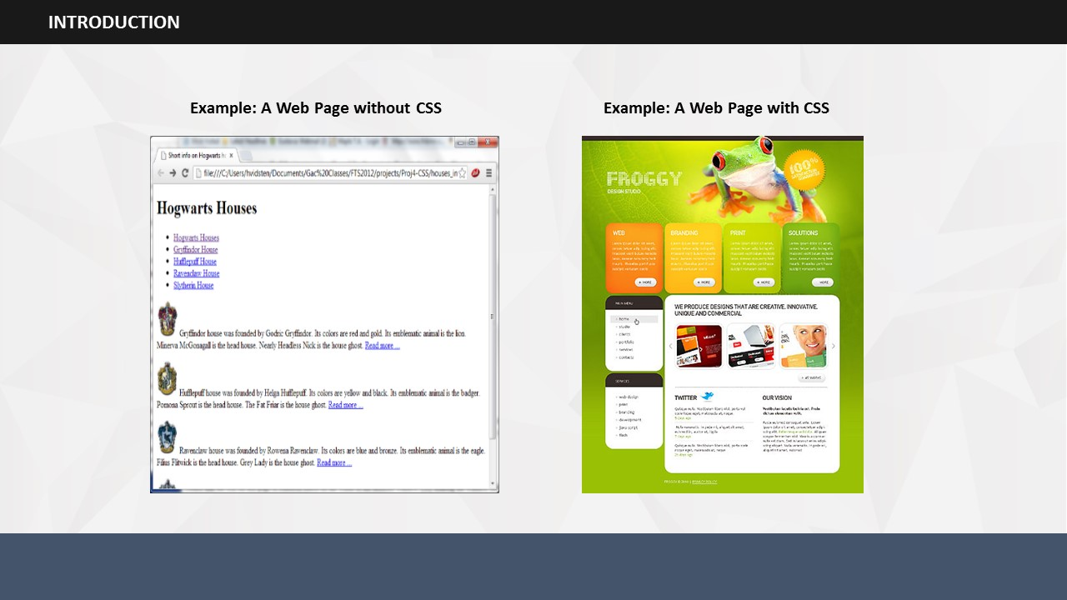

SUBTOPIC 2: WHY DEFINE CSS?

Say: See how a Web page looks with and without CSS.

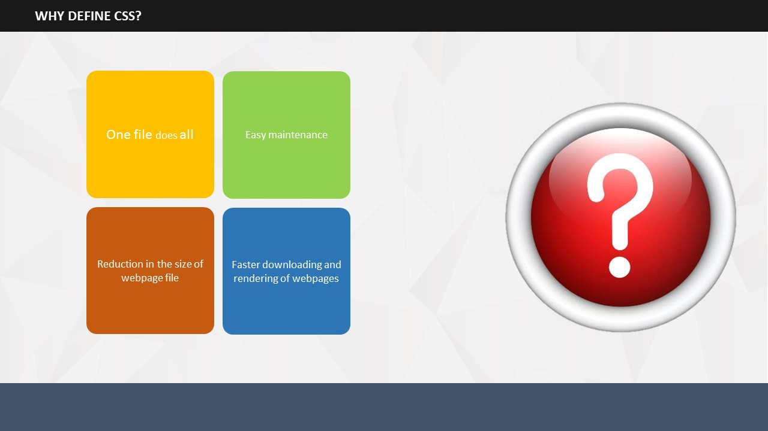

**Say:** In your opinion, why is it important to define style sheets important? How does it help web designers?   
  
**Do**: Invite participants to share their opinion on the importance of CSS. Since it’s a new topic, tell them it is perfectly fine even if they don’t know how CSS can help the designers!

1. **Say:** The reasons behind defining CSS are definitely more than one.
   * 1. **One file does all**: HTML files arrange the content in a website, but the presentation of this content using different fonts, colors, formatting, background & so on is done using a CSS. So, you can provide style instructions in a single file that is separate to the HTML. On linking all the pages of your website to this centralized style sheet, you can easily update the look of the website.   
          
        For example, if you wish to change the font style of the headings, you can add the instructions in the style sheet. One rule will change the font style of all the headings on all the pages.   
          
        This surely saves a lot of time! I am sure you all will agree!
     2. **Easy maintenance**: Since CSS requires fewer codes to manage the content, so less time is spent in addition or deletion of content. Moreover, fewer codes mean a lesser chance of coding errors!
     3. **Device-based customized presentation**:You can use different set of rules for different devices in style sheets. For example, you can set different rules to manage how a webpage should appear when accessed from a desktop and from a mobile phone.
     4. **Reduction in the size of webpage file**: Since the code required to style content is in a single file, so you may no longer need the codes on individual webpages. You can easily delete individual web page codes and reduce the size of the webpage file.
     5. **Faster downloading and rendering of webpages**: If a user has once visited your website, CSS typically gets downloaded and saved in user’s computer in cache. So, when the user revisits the site only the HTML is downloaded leading to faster download of the webpage. The webpage can be made to render faster by writing simple rules or instructions in the style sheets. This enhances the user experience by displaying the webpage faster.

## 

SUBTOPIC 3: CSS SYNTAX

1. **Say:** Before you could write your own style sheet, you need to know about the components that are required to define any style. In other words, it’s important to know the syntax of CSS.
2. **Say:** A CSS rule or style has two parts.
3. **Say:** Selector
4. **Say:** Property: Value Pair which is also called as declaration.
5. **Say:** CSS selectors are used to select the HTML elements. These elements can be manipulated using CSS codes.
6. **Say:** While writing a declaration, you can write one or more declarations separated by semicolons. The group of declarations is generally called as a declaration block.
7. **Say:** Let’s go through a few examples which will explain the two parts of the style syntax in detail.  
     
   **Do:** Encourage the participants to identify the selector and declaration block in the shown example.
8. **Say:** In the first example, p is the selector while rest of the part is the declaration consisting of two properties, color and alignment and their corresponding values, blue and left.
9. **Say:** The second example shows the style rule for the heading set to black color and font size 14.
10. **Say:** In the third example, the paragraph style is set to a colored background and font family Times New Roman.

**Do**: Ask participants to come up with some more examples of CSS. Give them 5 minutes to think. Then, invite a few of them to come in front and write their CSS examples on the flipchart for others.

1. **Say:** A few important guidelines that you need to follow here are:

* Always use semicolons to separate out multiple declarations in the declaration block.
* Always end a declaration with a semicolon.
* Start and end a declaration group by curly brackets.

**Do**: Point out to the example given on the screen and show how it follows the above mentioned guidelines.

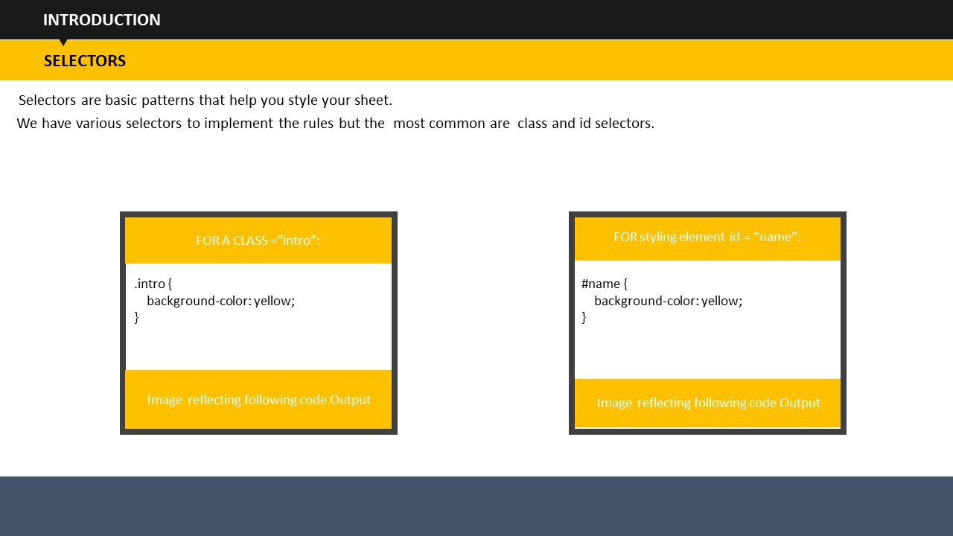

SUBTOPIC 4: SELECTORS

**Say:** Selectors are basic patterns that help you style your sheet.

**Say:** We have various selectors to implement the rules but the most common are class and id selectors.

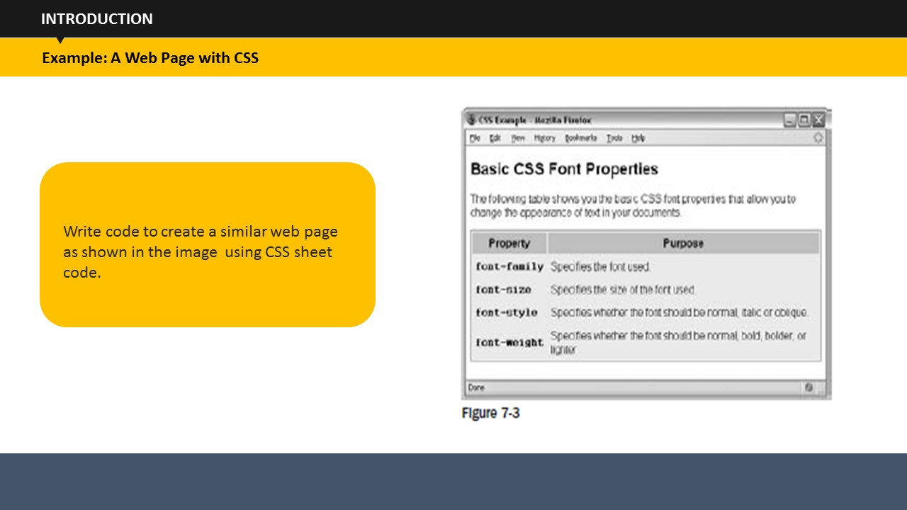Say: Let’s have a look at an example that shows how a set of CSS rules can transform the look of an XHTML page. CSS rules can live inside the XHTML document, although for this example we will be making a separate file to hold the CSS rules, and the XHTML page will contain a link to this file, which is known as a style sheet.

SUBTOPIC 5: WEB PAGE WITH CSS

## 

SUBTOPIC 6: INHERITENCE

**Say:** CSS properties that are set on an element through the cascade can be inherited by the child elements of that element. For instance, if a div element has font-size 30px then, assuming that none of the font-size declarations have been explicitly defined, a children will inherit that font-size value.

**Say:** For example, once the font - family property had been declared for the < body > element in the previous example, it applied to all of the elements inside the < body > element. This saves you from having to repeat the same rules for every single element that makes up a web page.

If another rule is more specific about which elements it applies to, then it will override any properties associated with the < body > element or any other containing element.

**Say:** The way in which some properties inherit saves you from having to write out rules and all the property -value pairs for each element and makes for a more compact style sheet.

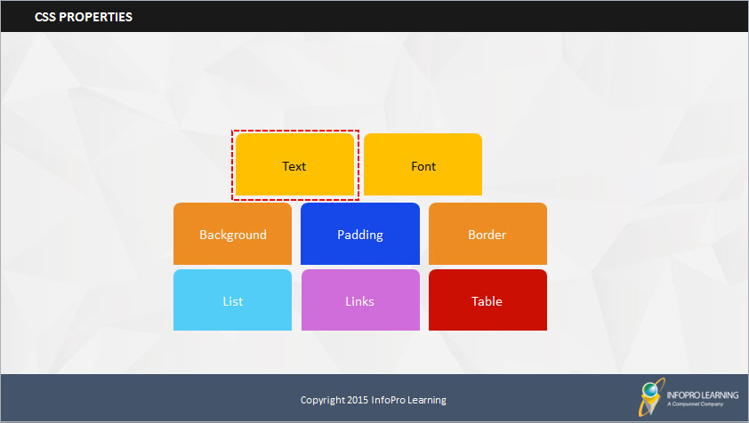

TOPIC 4 – CSS PROPERTIES

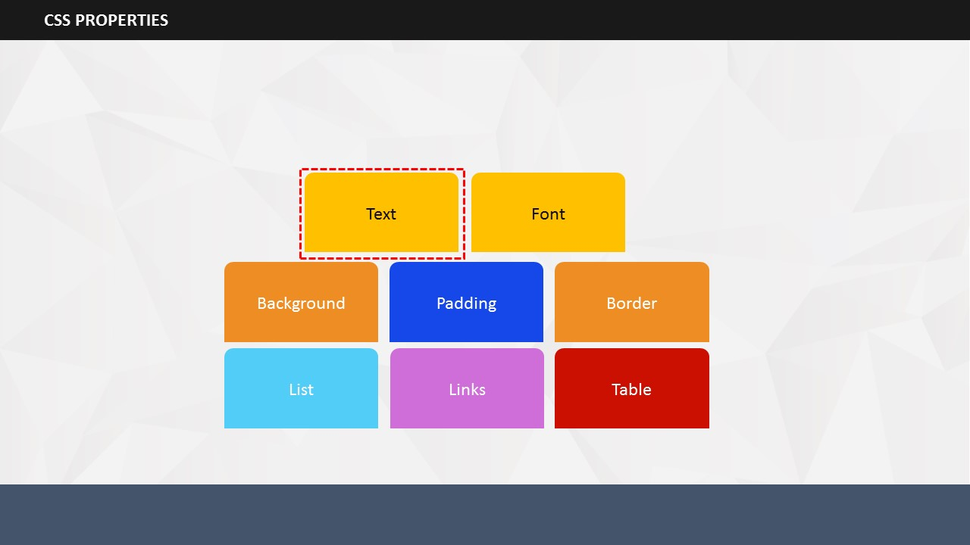

1. **Say:** Now, we will go through various types of properties associated with CSS. Once you are aware of these properties, you will be able to write a variety of CSS codes.
2. **Say:** The key properties that we will be covering are:
3. Text
4. Font
5. Background
6. Padding
7. Border
8. List
9. Links
10. **Say:** So, let’s start by understanding the CSS text properties.

### 

SUBTOPIC 1: TEXT

1. **Say:** While writing a CSS, you can style the text using various text formatting properties.

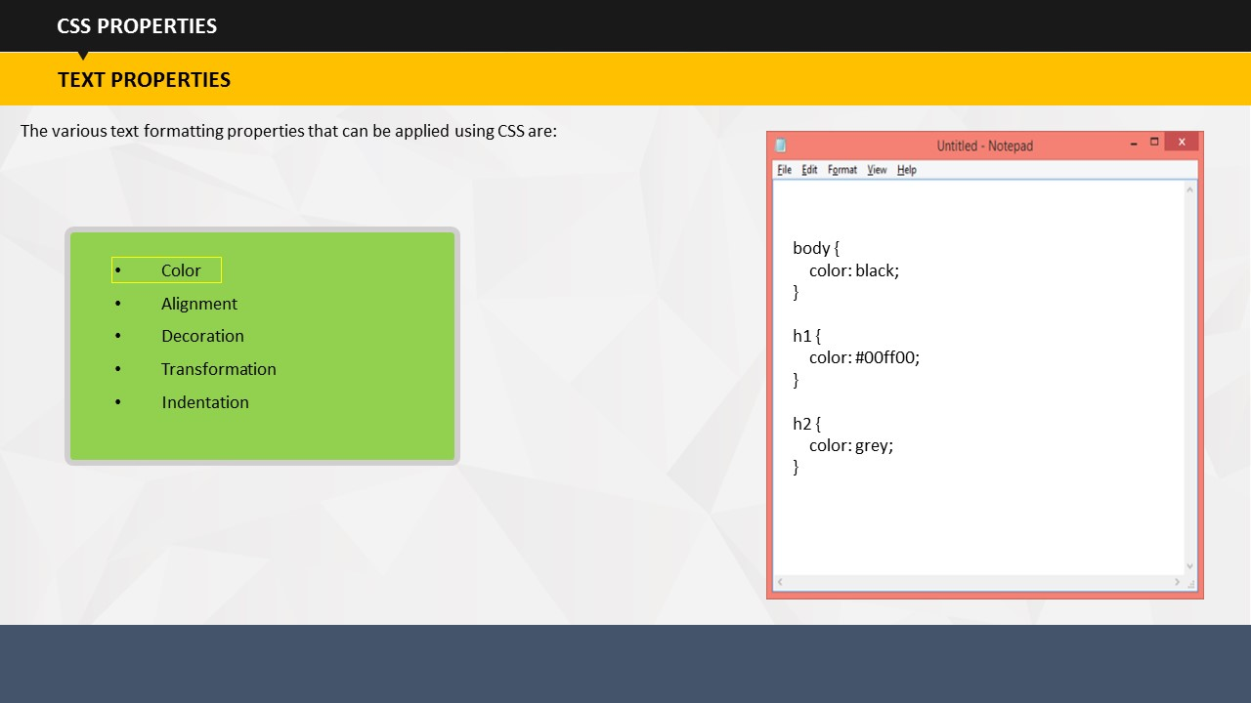

1. **Say:** The first property is color. You can set the color of the default page by defining the body selector. In the example shown on the screen the default page text is set to blue color. Similarly, you can set heading colors as well.

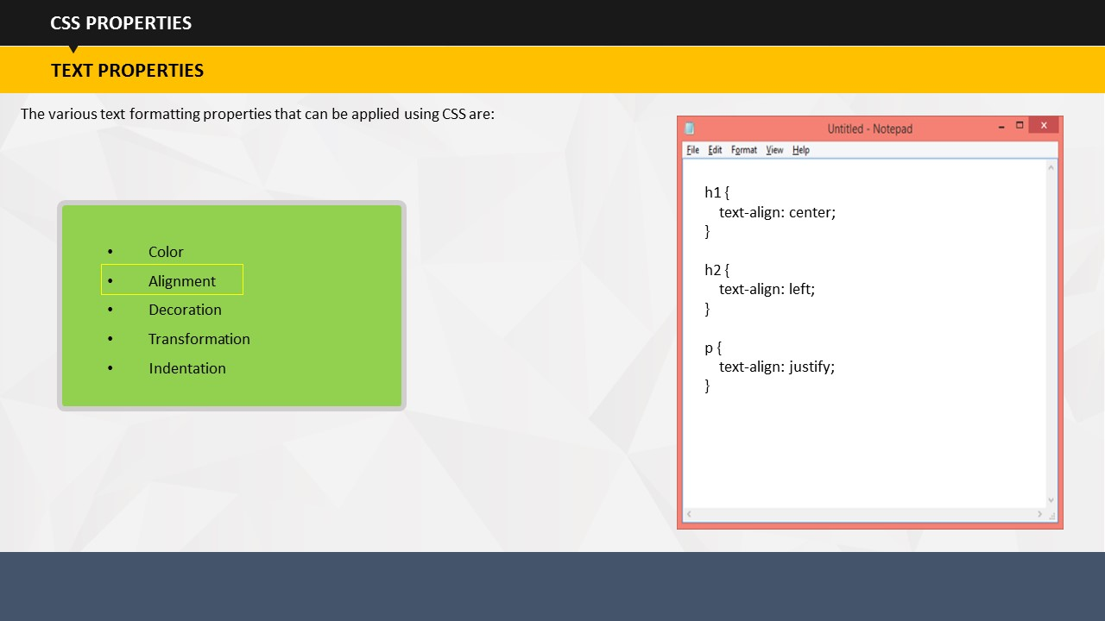

1. **Say:** The second property is text alignment. You can use styles to define the alignment of text. For example, the style defined on the screen shows that heading 1 should be center aligned, heading 2 should be left aligned, and paragraph text should be justified.

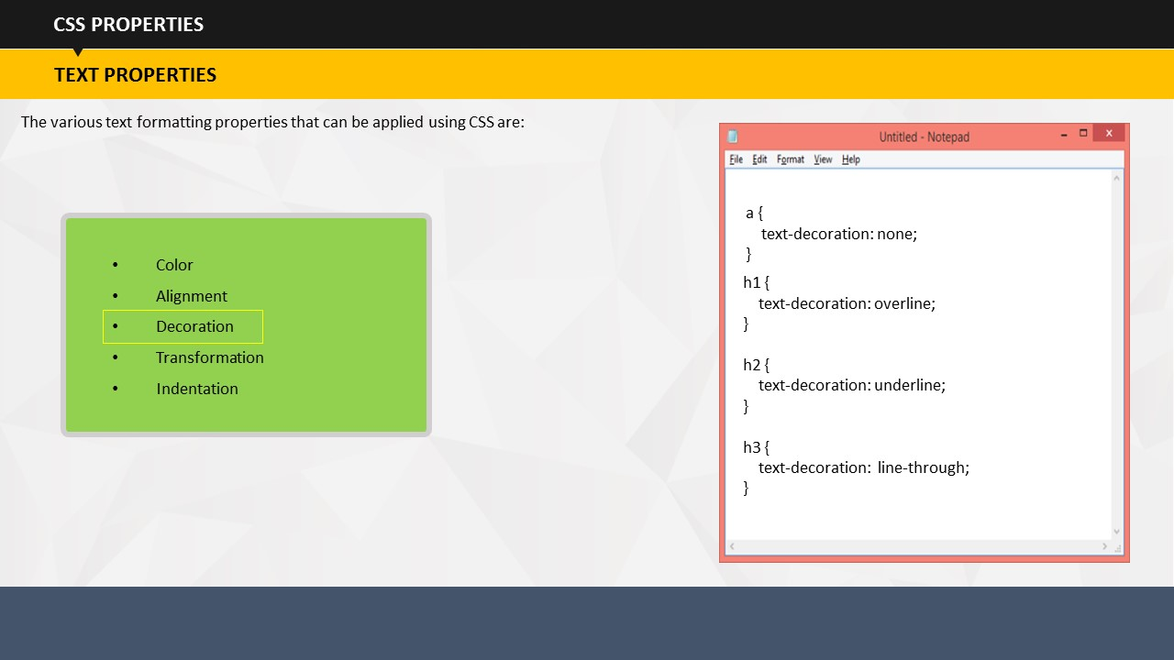

1. **Say:** The next property is decoration. Do not be misled by its name. It doesn’t do actual decoration of text. This property is basically used for removing underline from hyperlinks. You can also use it to add overline, underline, and line-through your text.

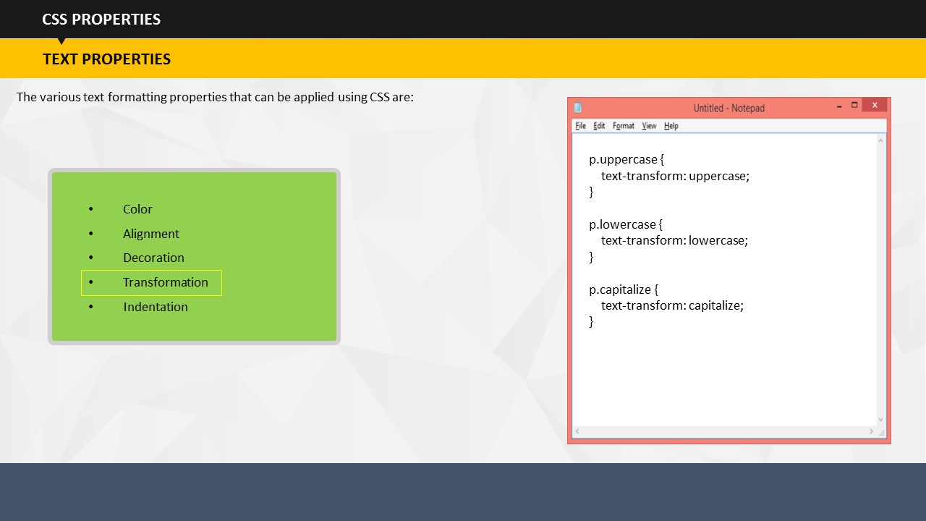

1. **Say:** The next property is transformation. This property is used for changing the casing of the text. Using it, you can control if your text will appear in uppercase or lowercase letters. You can also set the code to capitalize the first letter of each word.

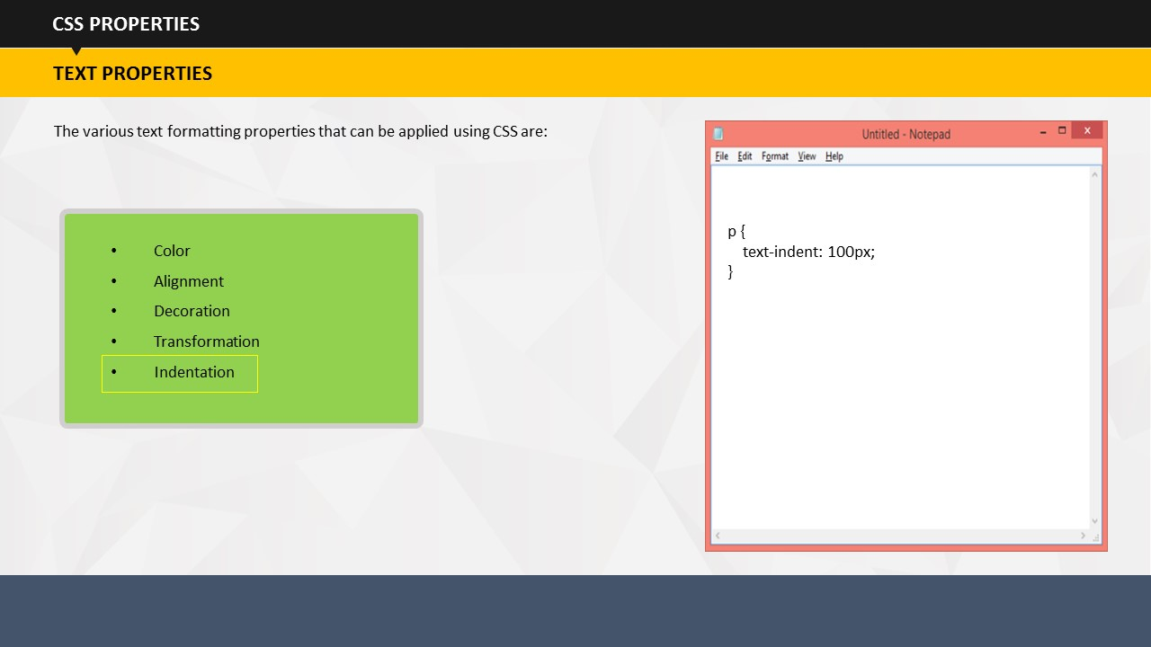

1. **Say:** The last text property is indentation. As the name suggests you can set the indentation of the text using this property, specifically of the first line of text. The example code shows that the indentation is set at 100 pixels.

### 

SUBTOPIC 2: FONT

1. **Say:** Next, let’s discuss about the font properties.

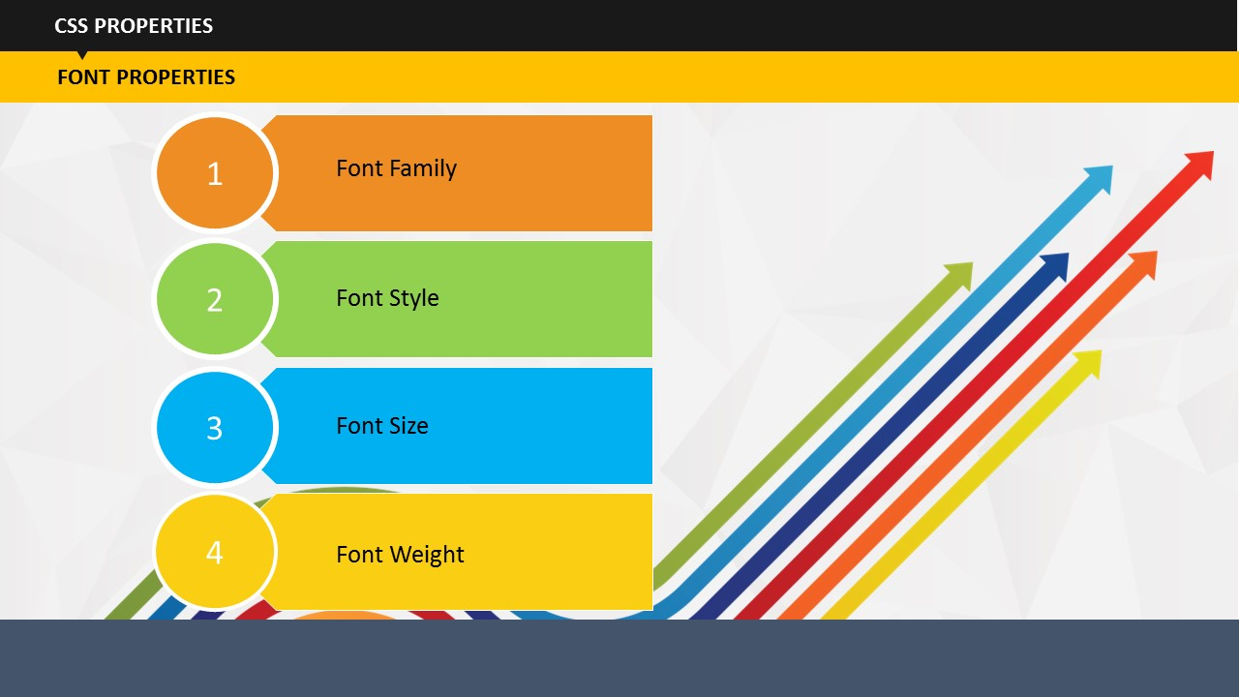

1. **Say:** Using font properties, you can set the font family, style, size, and weight.

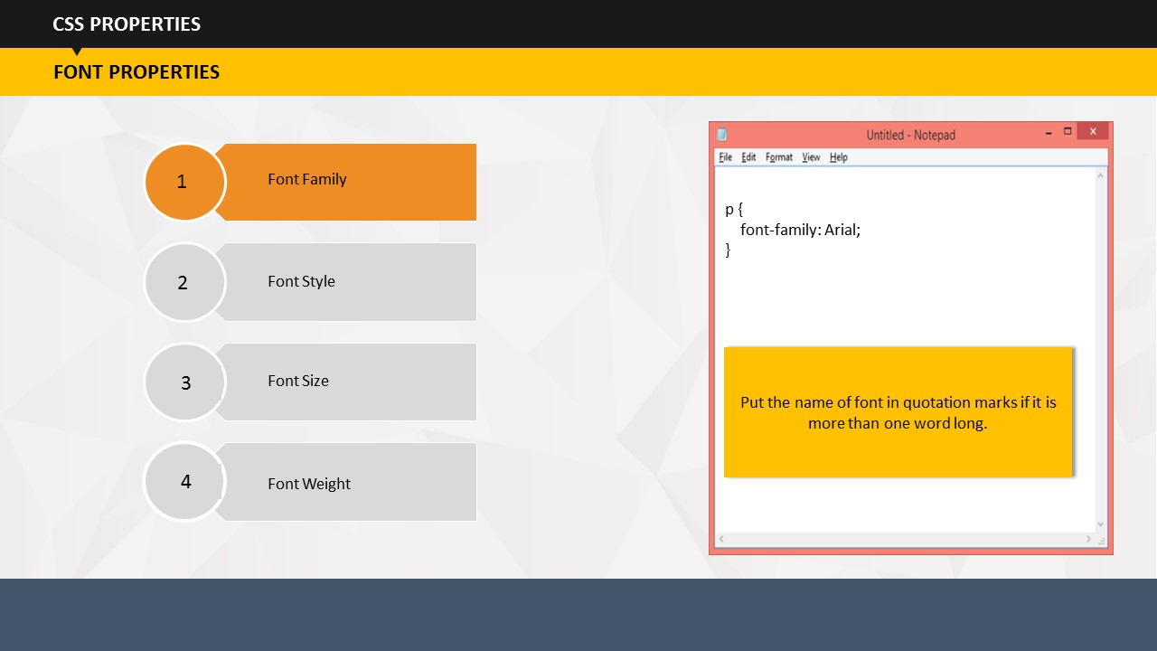

1. **Say:** By using font family property, you can set the type of font. For example, Arial, Times New Roman, Calibri, and so on.

An important point to take care of while setting font style is that the name of font should be placed in quotation marks if it is more than one word long. For example Times New Roman should be placed in quotation marks while Arial can be written without quotation marks.

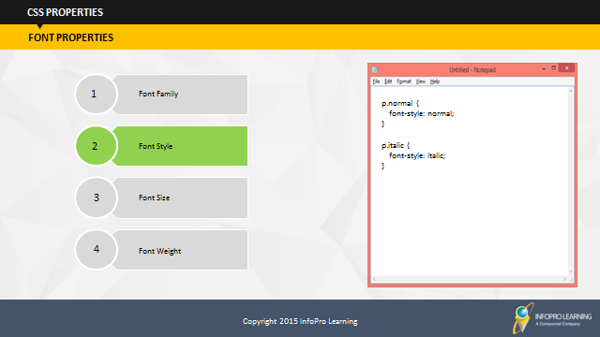

1. **Say:** Using font style, you can decide if you would like the text to appear in normal or italics form.



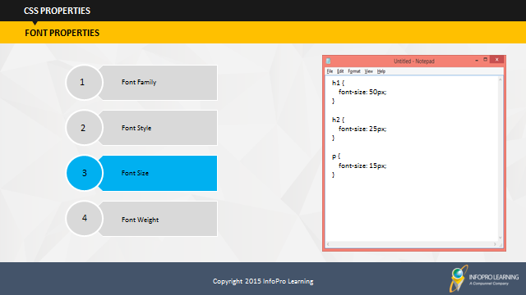

**Say:** You can set the size of headings, body text, etc. using code for font size.



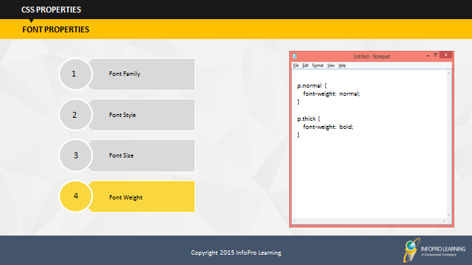

1. **Say:** Using code for font weight, you can define if you would like the text to appear as normal or in bold format.

### 

SUBTOPIC 3: BACKGROUND

1. **Say:** Next, let’s talk about the background. Using CSS, you can easily manage the background color as well as background image.

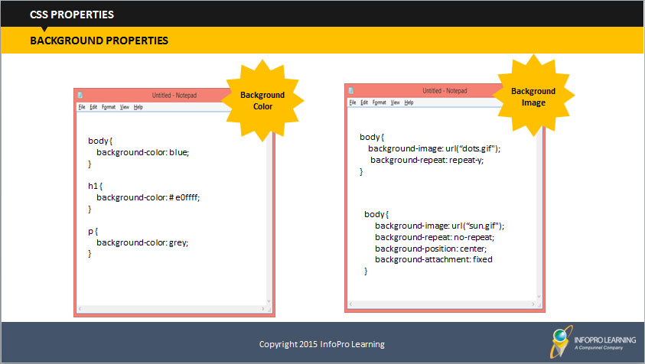

**Say:** You can set background colors for the background of the page, heading, and paragraph as shown by the codes given on the screen.

1. **Say:** Similarly, you can set an image to act as a background of your page by using the code given on the screen. In addition, you can add one more code if you would like to repeat the image. For example, the code given on the screen says repeat-y. That means the image would be repeated vertically. You can write x instead of y if you want to image to be repeated in a horizontal manner.
2. **Say:** If you do not want your background image to be repeated, you will have to add the no-repeat code.
3. **Say:** You can also fix the position of the image using background-position code. The example on the screen shows that the image is placed at center. You can change it to left, right, top, bottom, top left, right bottom, and as on.
4. **Say:** One last property of background style is the background-attachment. You can set this property to decide if you would like your background image to be fixed or scrolled with the rest of the page. The example code on the screen shows it is set to fixed, but as mentioned you can change it to scroll as well.

### 

SUBTOPIC 4: PADDING

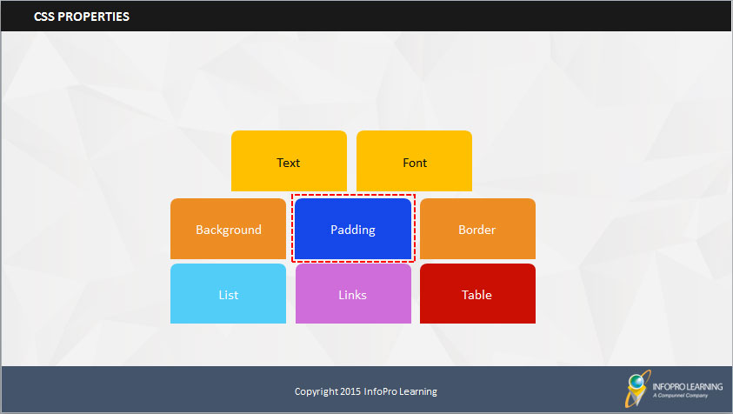

1. **Say:** The next property that we will focus on is padding.



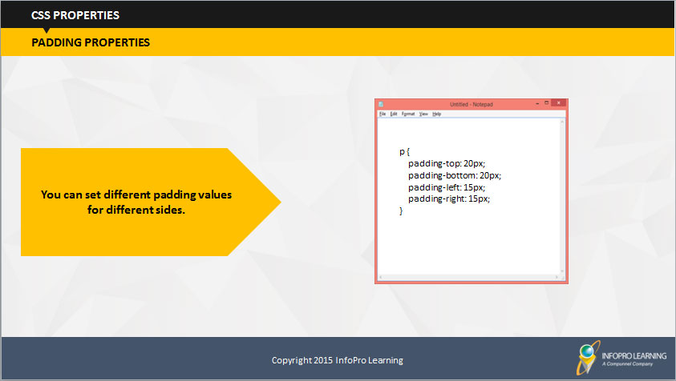

1. **Say:** Using CSS, you can define different padding for different sides. If you don’t know what padding is, no problem!   
     
   Padding is nothing but the space between the element content and the border around it. We can maintain this space using CSS. So, you can easily set the left, right, top, and bottom paddings using style codes as shown on the screen.
2. **Say:** You can set different padding values for different sides.

### 

SUBTOPIC 5: BORDER

1. **Say:** Now, let’s move on to the next property which is the border.



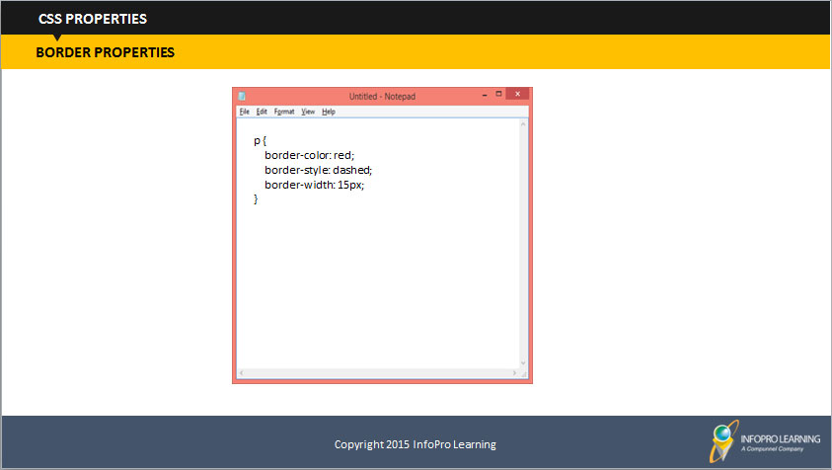

1. **Say:** You can specify the size, color, and style of an element's border using border property. By style, we mean if you want the border to be solid, dotted, dashed, double-lined, and so on.
2. **Say:** The example code on the screen shows that the border is of red color, dashed, and with a width of 15 pixels.

### 

SUBTOPIC 6: LIST

**Say:** Another important CSS property is list.

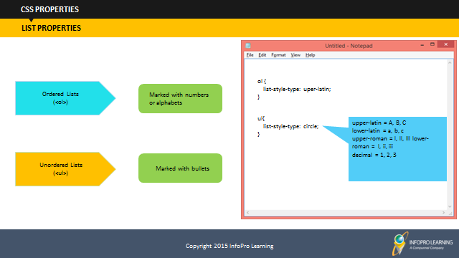

1. **Say:** So, what does this property do? It helps you in defining the list markers for ordered as well as unordered lists.
2. **Say:** In other words, it helps you decide if you would like all the ordered lists markers to appear in form of number or alphabets.
3. **Say:** Similarly, you can set how you would like the unordered list items to appear. You can use round circle, square, and more such styles. Alternatively, you can also use an image as the list item marker.

### 

SUBTOPIC 7: LINKS

1. **Say:** Let’s go to the links property.

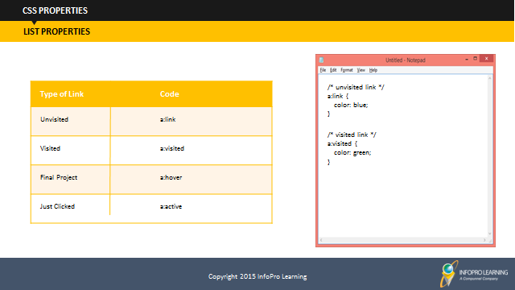

**Say:** Links can be styled in many ways. The style depends on the state of a link, for example if it is unvisited or visited. Different styles are available if the link if the user hovers over the link using mouse. You can also set a separate style for the links which have been just clicked.

1. **Say:** Take a look at the style given on the screen. It defines that unvisited links should be of blue color while the visited links should turn green.

## 

SUBTOPIC 8: TABLE

1. Say: Let’s go to the Table property.

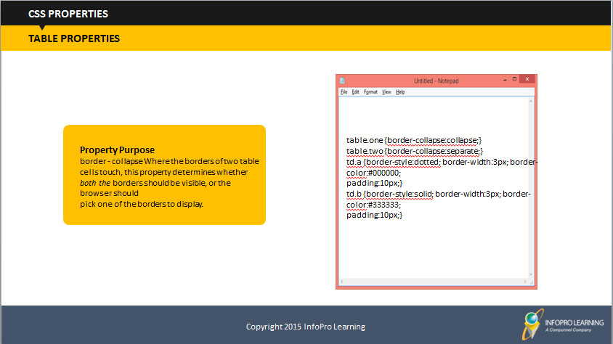

**Say:** **Property Purpose** border - collapse Where the borders of two table cells touch, this property determines whether *both the* borders should be visible, or the browser should pick one of the borders to display.

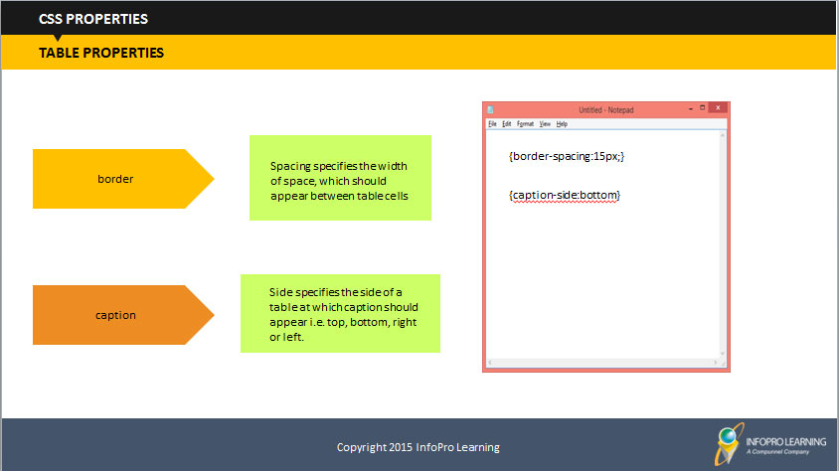

**Say:** Border: Spacing specifies the width of space, which should appear between table cells

Caption: Side specifies the side of a table at which caption should appear i.e. top, bottom, right or left.

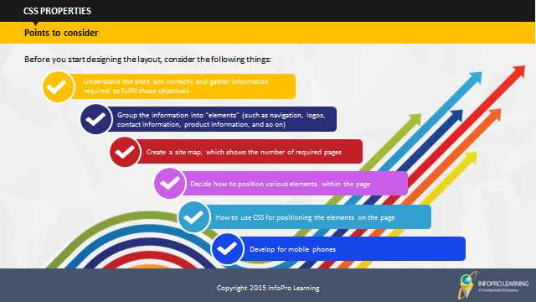

**Say:** Understand the site’s aim correctly and gather information required to fulfill those objectives

SUBTOPIC 9: POINTS TO CONSIDER

* Group the information into “elements ” (such as navigation, logos, contact information, product information, and so on)
* Create a site map, which shows the number of required pages
* Decide how to position various elements within the page
* How to use CSS for positioning the elements on the page
* Develop for mobile phones

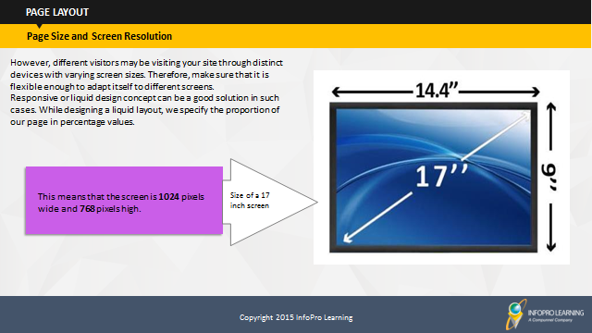

## Say: Today, we have PCs of distinct screen sizes and resolutions. Where in the resolution of a screen means pixel per inch.

TOPIC 5 – PAGE LAYOUT

SUBTOPIC 1: PAGE SIZE AND SCREEN RESOLUTION

However, distinct visitors may be visiting your site through distinct devices with varying screen sizes. Therefore, when you plan a site, make sure that it is flexible enough to adapt itself to different screens.

For instance, if you want set width of your Web page in proportion to the Website’s width, i.e. 75% of the width of the Web browser, then the page border will adjusts itself accordingly without losing content.

Say: However, distinct visitors may be visiting your site through distinct devices with varying screen sizes. Therefore, make sure that it is flexible enough to adapt itself to different screens.

Responsive or liquid design concept can be a good solution in such cases. While designing a liquid layout, we specify the proportion of our page in percentage values.

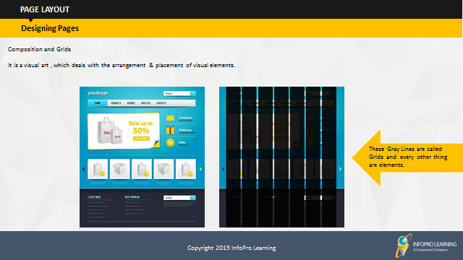

SUBTOPIC 2: DESIGNING PAGES

Say: Composition is a visual art, which deals with the arrangement and placement of visual elements.

Say: It is important to distinguish between the use of the word elements in terms of designing pages (where it means items on the page such as navigation, branding, articles/products, and so on) and the more technical use of the word (because an element can also mean a pair of tags and their content, such as a < b > bold < /b > element).



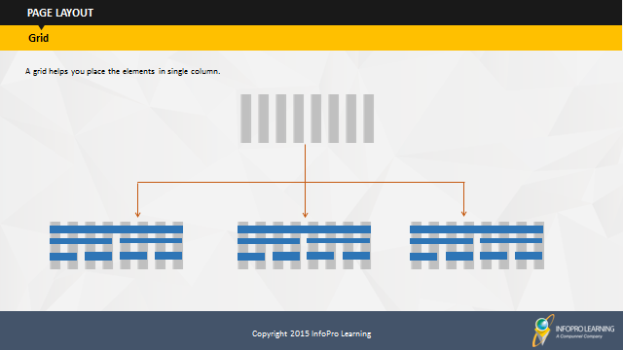

Say: A grid helps you place the elements in single column

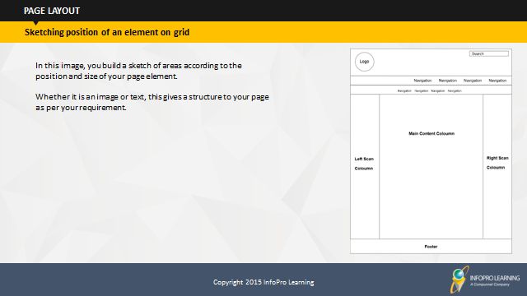

SUBTOPIC 3: SKETCHING POSITION OF AN ELEMENT ON GRID

Say: In this image, you build a sketch of areas according to the position and size of your page element.

Weather it is an image or text, this gives a structure to your page as per your requirement.

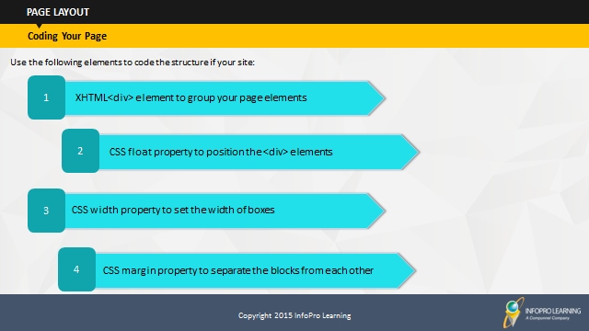

SUBTOPIC 5: CODING YOUR PAGE

Say: Use the following elements to code the structure if your site:

* XHTML<div> element to group your page elements
* CSS float property to position the <div> elements
* CSS width property to set the width of boxes
* CSS margin property to separate the blocks from each other

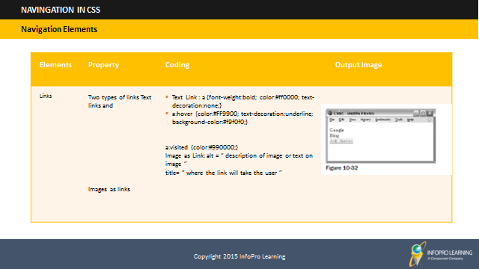

SUBTOPIC 1: NAVIGATION ELEMENTS

TOPIC 6 – NAVIGATION IN CSS

Do: Discuss the navigation elements shown in the table.

Say: A user navigates the site in one of three ways:

* Using provided menu
* Browsing through the links provided in text and other parts of the page
* Searching for relevant items of information

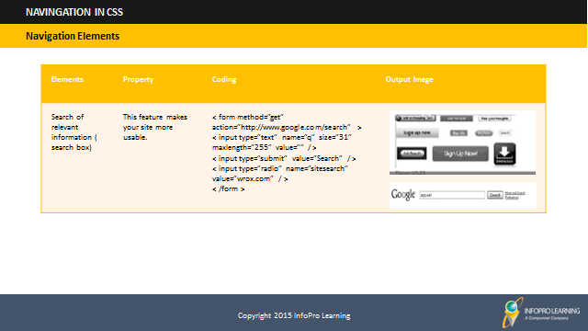

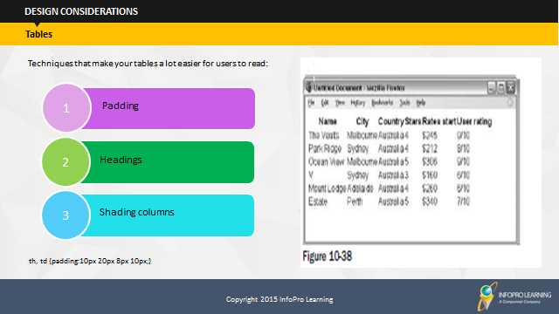

**Say:** Allowing padding around each item is important so that there is space between each cell in the table and between the contents of cell or any border, if they are used. When the content of table cells is allowed to touch either the neighboring cells or the edges of any cells, Padding becomes difficult.

SUBTOPIC 1: TABLES

TOPIC 7 – DESIGN CONSIDERATIONS

These techniques make your tables a lot easier for users to read:

* Padding
* Headings
* Shading columns

Padding: th, td {padding:10px 20px 8px 10px;}

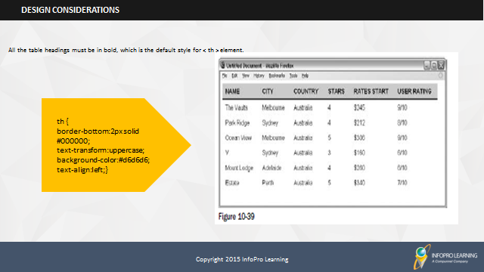

**Say:** Try to make headers uppercase and underline the headings with a dark line to separate the headings from the content:

All the table headings must be in bold, which is the default style for < th > element.

th {

border-bottom:2px solid #000000;

text-transform:uppercase;

background-color:#d6d6d6;

text-align:left;}

SUBTOPIC 2: HEADINGS

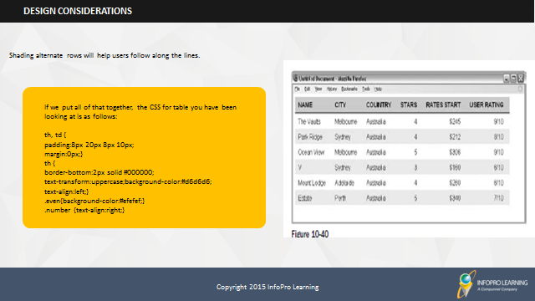Say: Shading alternate rows will help users follow along the lines.

SUBTOPIC 3: SHADING ALTERNATE ROWS

You should only shade every other line, preferably using a slightly lighter shade than the heading, as shown in Figure 10 - 40. You might also find it helpful to align numerical data to the right of the column and leave words aligned to the left.

If we put all of that together, the CSS for table you have been looking at is as follows:

th, td {

padding:8px 20px 8px 10px;

margin:0px;}

th {

border-bottom:2px solid #000000;

text-transform:uppercase;background-color:#d6d6d6;

text-align:left;}

.even{background-color:#efefef;}

.number {text-align:right;}



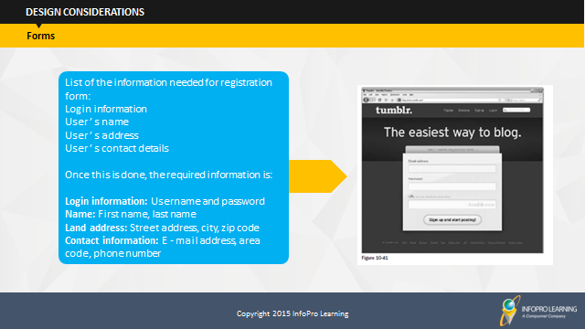

SUBTOPIC 4: FORMS

Say: As far as designing of form is concerned, you need to be particular about its look. If your site includes a form, it needs to have good design, otherwise people won’t fill it.

List of the information needed for registration form:

Login information

User ’ s name

User ’ s address

User ’ s contact details

Once this is done, the required information is:

**Login information:** Username and password

**Name:** First name, last name

**Land address:** Street address, city, zip code

**Contact information:** E - mail address, area code, phone number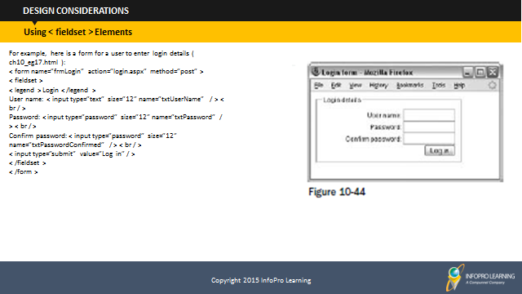

Using <fieldset> elements

For example, here is a form for a user to enter login details ( ch10_eg17.html ):

< form name=”frmLogin” action=”login.aspx” method=”post” >

< fieldset >

< legend > Login < /legend >

User name: < input type=”text” size=”12” name=”txtUserName” / > < br / >

Password: < input type=”password” size=”12” name=”txtPassword” / > < br / >

Confirm password: < input type=”password” size=”12”

name=”txtPasswordConfirmed” / > < br / >

< input type=”submit” value=”Log in” / >

< /fieldset >

< /form >

< /form >



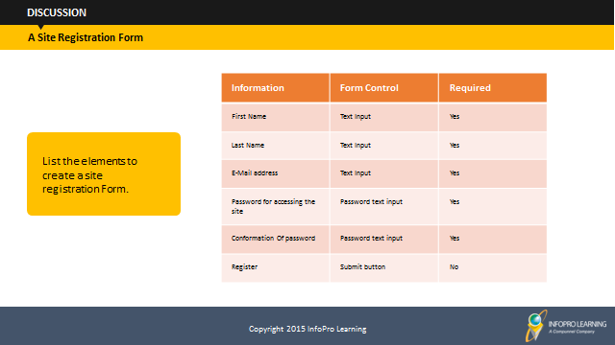

**Discussion:** List the elements to create a site registration Form.

Ask the students to create a list of elements that are required to design a site registration form.

# 

SUBTOPIC 5: CREATING A STYLE SHEET

1. **Say:** Now that you’ve had an understanding of different types of style codes, let’s create a style sheet where we can apply the styles that we just learned. So, let us start by outlining the various steps that you need to perform to create a new CSS.
2. **Say:** Open a text editor (SimpleText for Mac or Notepad for Windows).
3. **Say:** Enter the text as shown on the screen:

<html>

<head>

<style>

body {background-color: #F0F8FF;}  
h1 {color: blue; text-align: center; font-size: 40px; font-weight: bold; font-family: Arial;}  
p {text-align: left; font-family: "Times New Roman"; font-size: 20px}  
</style>  
</head>  
<body>  
<h1>My First CSS</h1>  
<p>Hello everyone! This is my first CSS and there is more to come...</p>  
</body>  
</html>

**Say:** Save the document as: *myfirstcss.html*. Your file can be saved as either an htm or html file. Remember to save your document on the computer in a place that you can find it again.

1. **Say:** Preview your new CSS using any browser.

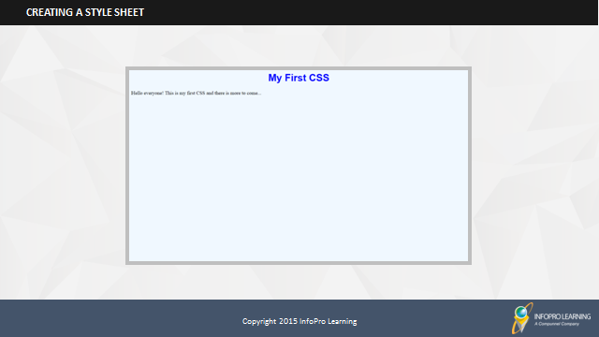

1. **Say:** If all went as planned, your file should look like this in your browser. Congratulations! You have successfully completed your first CSS.
2. **Say:** You can continue to build on this CSS by adding more styles to it.

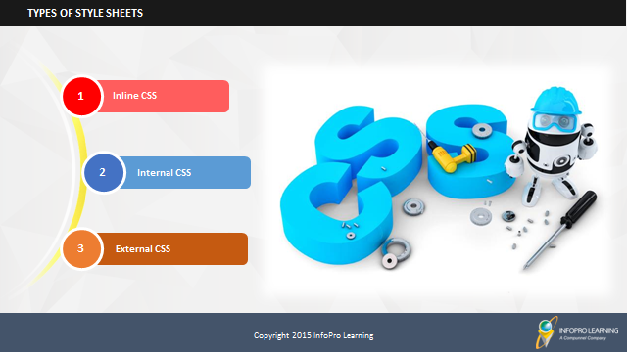

**Say:** There are three types of style sheets – Inline, Internal and External. We will learn about each style sheet and how it can be used.

SUBTOPIC 6: TYPES OF STYLE SHEETS

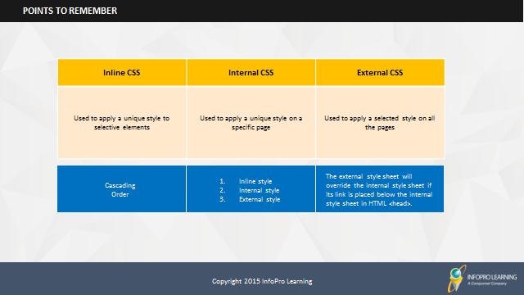

SUBTOPIC 7: POINTS TO REMEMBER

1. **Say:** So, remember that to apply a unique style to an element, we use inline style.
2. **Say:** On the other hand, to apply a style at a page level we use an internal CSS.
3. **Say:** When the style has to be applied to all the pages, we use an external CSS.
4. **Say:** When all the three types of style sheets are present the cascading order would be such that the inline style would have the highest priority followed by the internal style sheet and the last would be the external style sheet.
5. **Say:** An important point to note is that if you will place the link to the external CSS below the internal CSS in HTML <head>, the external style sheet will override the internal style sheet.
6. **Say:** With this we come to end of the key topics associated with CSS. Let’s have a quick recap of what we learned in this session.

## 

TOPIC 8 – USING INLINE CSS

**Say:** So, let’s start with inline style.

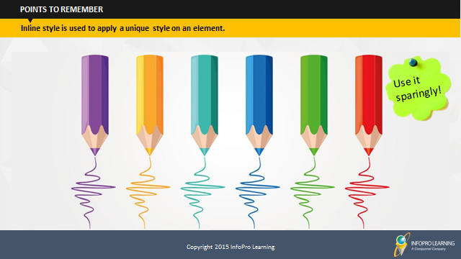

## 

SUBTOPIC 1: WHAT IS AN INLINE CSS?

**Say:** The inline style is used when you want to apply a unique style on an element. But, it is advised to use this style sparingly otherwise it defeats the true purpose of having a style sheet in place if you have to define a unique style for every other element.

1. 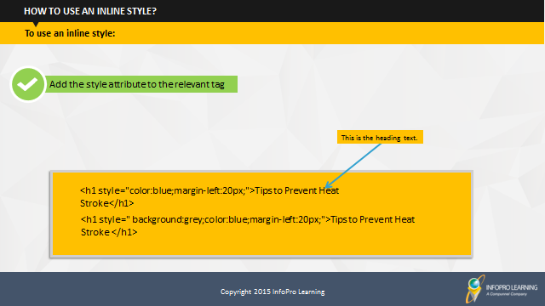 **Say:** To use inline styles, you simply have to add the style attribute to the relevant tag.

SUBTOPIC 2: HOW TO USE AN INLINE STYLE?

1. **Say:** Let’s look at an example that will explain how to do this. Assume that you want to change the color and alignment of the heading of a specific page. So, how would the inline code look like?  
     
   **Do**: Ask the participants to guess the code. Next, reveal the code on the screen.
2. **Say:** Let’s see how the code would look like if we want to add a background color?

**Do**: Ask the participants what addition should be done to the code in their opinion. Invite a few participants to come and write the updated code for rest of the class.   
  
**Do**: Next, reveal the answer on the screen.

1. **Say:** We can make the required change by a simple addition of the background value to the code.
2. **Say:** It’s fairly simple and you can modify the code based on the specific requirements. That’s what inline style is all about!   
     
   **Do**: Stress on the fact that this style should be used sparingly.

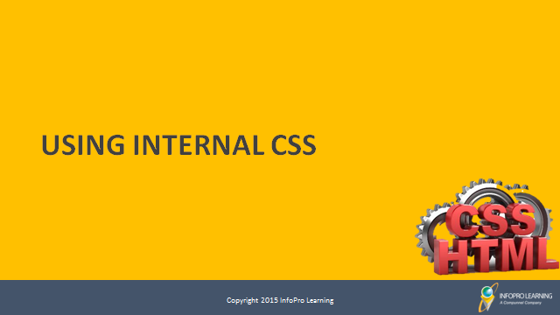

TOPIC 9 – USING INTERNAL CSS

## 

SUBTOPIC 1: WHAT IS AN INTERNAL CSS?

**Say:** Next, let’s discuss about the internal CSS and how we can use it.

We use an internal CSS when we want to incorporate a unique style to a single page. This is where it differs from an inline CSS which we learned is used to apply a unique style to an element.

## 

SUBTOPIC 2: HOW TO USE AN INTERNAL CSS?

1. **Say:** To use an internal CSS, you should define it within the <style> element, inside the head section of HTML page.
2. **Say:** Let’s take a look at an example. The example here shows the specific style of a page in terms of background color and page heading.
3. **Say:** Internal CSS are really helpful if you want to style only one page and even if you want different pages to follow different styles.

# 

TOPIC 10 – USING EXTERNAL CSS

## 

SUBTOPIC 1: WHAT IS AN EXTERNAL CSS?

**Say:** Let’s talk about the external CSS. Now that you know about internal CSS, can anyone define the external CSS?  
  
**Do**: Encourage the participants to share their understanding of an external CSS based on what the just learned.

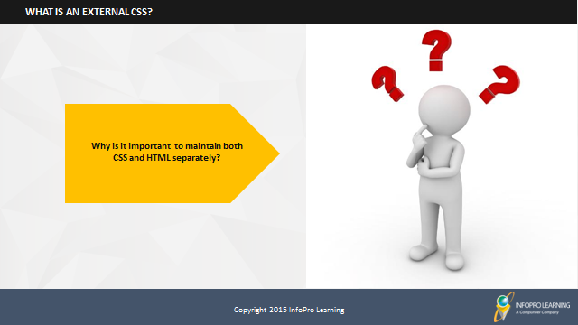

1. **Say:** An external style sheet maintains both CSS and HTML separately. You must be thinking what purpose does it serve?  
     
   **Do**: Ask participants if they can tell the benefit of keeping CSS and HTML separately.
2. **Say:** The files help in maintaining the content part and the design of page separately. So, if you wish to change the look and feel of a website, you just need to update the CSS part! Isn’t this amazing? Imagine how much time it would save for a web designers if they can differentiate between content (HTML) and design (CSS). In addition, it’s quite easy to reuse the codes if your CSS file is separate from HTML.

## 

SUBTOPIC 2: HOW TO USE AN EXTERNAL CSS?

1. **Say:** An external style sheet contains only CSS code. You can recognize such files by their file extension, which is ".css". You can reference the external style sheet in your HTML using the <link> element. To use an external CSS, simply place the <link> element inside the head section.
2. Take a look at the example given on the screen.To insert an external sheet enter its name in place of the red highlighted text. For example, you can enter the name of the style sheet that we created some time ago: *myfirstcss.css*  
    **Do**: Stress on the importance of saving the file in the .css format and that the file should not contain any html tag.

# 

SUBTOPIC 1: RECAP

TOPIC 11 – MODULE SUMMARY

**Duration:** 10 Minutes

**Say:** It’s time to review what we have learned so far. I want you all to write in the space given in your participant’s guide, what you have learned today.

**Say:** Let’s outline the learning from today’s session. (After giving 5 minutes time for writing summary points)

**Do:** Invite participants to raise their hands and share their take-away and leanings from each topic.

**Facilitator’s Notes:**

**Do:** Check if all the points given here are covered in the summarization activity.

**RECAP - INTRODUCTION TO CSS**

**Say:** In this module, we learned that:

* A CSS is used to define the look and feel of HTML elements in a webpage.
* A CSS rule has two parts: Selector and Property: Value Pair (or Declaration).
* Using CSS, a variety of properties can be defined such as Text, Font, Background, Padding, Border, List, Links, and Table.
* Effect of variable screen resolution on the look and feel of our website.
* We see how we can give a professional look to the pages that we have created using grids concept rather-than defining the areas of elements randomly.
* What are the basic standards for some basic elements of pages like header, footer, and page logo?
* How navigation elements and customizing its properties help us in creating a structured website
* Properties of tables and its benefit to categorize the elements to give a feel of well-structured look to our website pages.
* Basic elements of a web form and how to code your first CSS base Web form.
* The CSS sheets are of three types – Inline, Internal, and External.

**Say:** In this module, we learned that:

* An inline style sheet is used to apply a unique style on an element.
* An inline style is applied by adding the style attribute to the relevant tag.
* An internal style sheet is used to incorporate a unique style to a single page.
* An internal style is applied by defining it within the <style> element, inside the head section of HTML page.

**Say:** In this module, we learned that:

* An external style sheet is used to separately maintain CSS and HTML.
* An external style is applied by placing the <link> element inside the head section.
* When all three types of style sheets are present the following cascading order is followed:
  1. Inline
  2. Internal
  3. External

## 

SUBTOPIC 2: FINAL TIPS AND SUMMARIZATION

**Say:** This is the end of session. I hope you understood the concepts that we covered today and would be able to apply them while working.

**Do**: Use this moment to clarify any doubts and provide any tips to the learners.

# State whether the following statement is True or False. A CSS makes the content easy to manage since it requires fewer codes.

TOPIC 12 – CHECK YOUR UNDERSTANDING

* 1. **True**
  2. False

1. Choose the correct option.  
     
   Which of the following is used to select the HTML elements while defining a CSS  
   1. Declaration Block
   2. Property: Value pair
   3. **Selector**
   4. CSS Syntax
2. Choose the correct option.  
     
   Which of the following style sheets is at the bottom of the cascading order?  
   1. **External**
   2. Internal
   3. Inline
3. State whether the following statement is True or False.  
     
   An external style sheet is used to incorporate a unique style to a single page.
   1. True
   2. **False**
4. Choose the correct option.  
     
   Which of the following style sheets should be sparingly used?
   1. **Inline**
   2. Internal
   3. Externa



**ITES Functional Skills Training**

# LAB EXERCISES

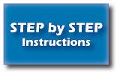

* You may want to bring your Facilitator Guide to labs to refer to the content and examples.
* If the participants have a question, tell them that they can ask you for help, or look at their Participant Guide or lecture slides.
* Encourage the participants to talk to their classmates; tell them it is okay to share code and ideas during lab.
* Tell the participants that they are not expected to finish all the exercises. They simply need to do as much as they can in the allotted time. They don't need to finish the rest after they leave the lab.
* Before they leave, tell them to check in with you to get credit for their work.

**Say**: As the first exercise today, you will create a simple style sheet using any simple text editor (Notepad, WordPad etc.).



**Exercise 1**: **Creating a CSS (2 hours)**

Describe this exercise. Ask the participants to read carefully and start.

Create a CSS with the following style details:

* Background color: #d0e4fe
* Heading (h1):
  + Title: My First CSS
  + Color: Orange
  + Alignment: Center
* Paragraph (p):
  + Para Text: This is my first CSS exercise. This is a paragraph style.
  + Color: Blue
  + Alignment: Left

**Say**: Now, it’s time create your own style sheet. All the best!

**Do**:Ask them if they have clearly understood the example and know what this exercise requires them to do. Once you get the approval, tell them that now they can create their own style sheet.

**Exercise 2**: **Using an External CSS (2 hours)**

Once you have created your own style sheet, use it as an external CSS.

To do this, edit the following code and attach your own style sheet to it.

<html>  
<head>  
</head>

<body>  
<h1>Steve Jobs</h1>  
<p> Steven Paul "Steve" Jobs was an American entrepreneur, marketer and inventor, who was the cofounder, chairman, and CEO of Apple Inc..</p>  
  
<p> Through Apple, he was widely recognized as a charismatic and design-driven pioneer of the personal computer revolution and for his influential career in the computer and consumer electronics fields, transforming "one industry after another, from computers and smartphones to music and movies." Jobs also funded what would become Pixar Animation Studios; he became a member of the board of directors of The Walt Disney Company in 2006, when Disney acquired Pixar.</p>

</body>  
</html>

**Hint:** Ask the participants to add a <link> element in <head>. The <link> element should have "rel", "type", and "href" attributes.

(*type=”text/css”href=”<name of your style sheet>”.css />)*

Now, attach your own style sheet to the given code. All the best!

**Say**: If you finish all your exercises and the lab time is up, you may stop working. You don't need to complete the remaining exercises unless you want to for fun.

**Say**:Great work!